**Data Page Rule: (Shared Pages)**

* **Data Page is a Data Model Rule.**
* **Purpose: Load Data Once & Share the Data across the application within same Transaction or diff Transactions.**
* **Data Pages are created under Data Classes. (Table Class)**
* **Data Pages are introduced only in 7 Version**
* **Before 7 Version we have Declare Pages (Similar to Data Page Rule). Declare Pages is a Decision Rule.**
* **Data Page is an Instance of Rule-Declare -Pages**
* **Data Page Names will start with D_**

**Dis advantages of using Obj-Browse & Report Definition loading Dynamic Data:**

* **Clipboard Memory will be high because for every wo separate User Pages will be created.**
* **Source rule will be called every time**
* **More Response time & Less Performance**
* **The Solution for above things is Data Page Rule.**

**Data Page Advantages?**

* **Clipboard size will be reduced, because wo data will be assigned to Data Pages in Clipboard. Only 1 Data Page will be created & the same data page will be reused/Shared/Copied with in same flow or Different flows by One operator Or Multiple Operators.**
* **Source rule will be called only once**
* **Response time is very less & Performance is high**
* **First PRPC Looks for Data Page in Clipboard, if Data Page not available then it will check for Activity or Report Definition**

**Purpose of Data Page:**

**Data Pages are Shared Pages. We will load Data once & reuse the Data across the application with in single Work Object or Multiple Work Objects.**

**Data Page Sources:**

**In Data Page rule we cannot define direct source (There is no Built in Source to Load Records)**

**Source can be defined by using Report Definition, Activity, Connectors, data transform**

**Data Page Types/Scope of Data Page:**

**3 Types: Thread, Requestor & Node**

**Thread:**

**Within Same Transaction only data can be used/shared. (Data will be loaded for first Page & from next page data will be copied with in Same Transaction)**

**Ex:**

**Flow1: Mapping Data page in As1 & As2**

**Start--------Ass1-------Ass2---------End**

**Ass1: State (Data Is Loaded)**

**Ass2: State (Shared/Copied)**

**1st WO C-1: Load & Copy**

**2nd WO C-2:  Load & Copy**

**Requestor:**

**Here Requestor is One Operator. For One Operator, Data Pages is available for Sharing with in one requestor Session.**

**Ex:**

**Start--------Ass1-------Ass2---------End ( Flow 1)**

**Start--------Ass3-------Ass4---------End  ( Flow 2 )**

**Operator Login to Application @ 8 AM**

**1st WO:  Data will Load & Copied**

**2nd WO:  Copy**

**3rd WO: Copy**

**1 PM: Lunch Break (Logout from the Session)**

**2PM: Login**

**4th WO: Data Will Load again & Copy**

**5th WO: Copy**

**Node:**

* **Multiple Operators can access the Data Page & Reuse**
* **Shared across multiple requestors, who logon to the application from same node, but not with requestors of another node.**
* **i.e. within same node who are connected every one can access the Data Page & Reuse.**
* **When working at Node Level we have to specify Access Group.**

**Thread- from one flow if you want to load data in multiple pages go for Thread.**

**Requestor- from multiple flows by one operator with in requestor session if they want to load & copy**

**Node - In multiple flows by multiple developers want to Load & copy go for Node**

**Working with Data Pages:**

**Req:**

**Populate State data from States table using source as Data Page. Inside Data Page Use Source As Report Definition to load the Records.**

**Use Existing Report Definition: (To Fetch Data From states Table)**

**Data Page - Thread:**

**Create Data Page Under States Table Class using Scope as Thread:**

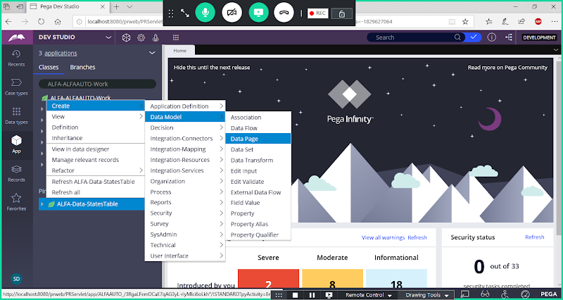

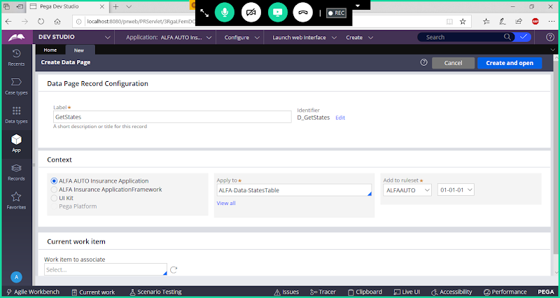

**Open**

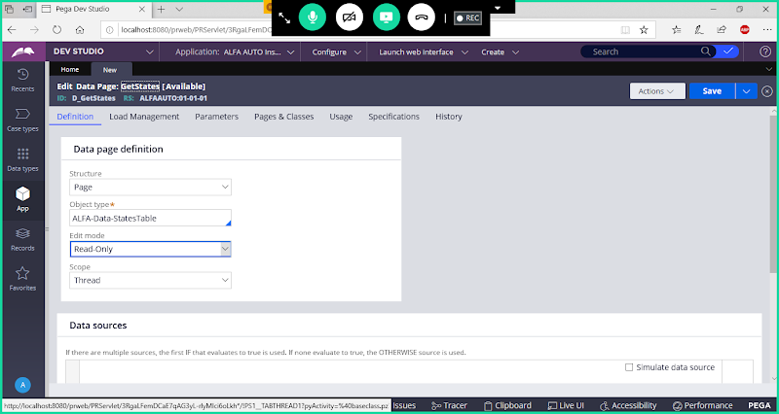

**Change Structure : List**

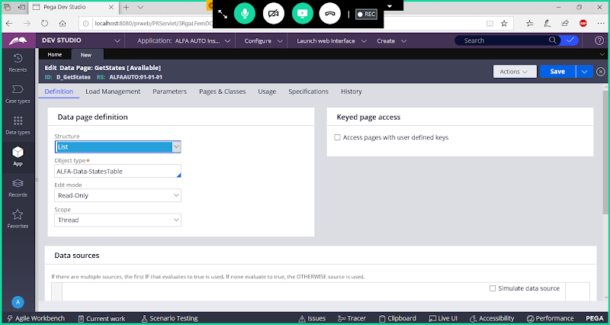

**Scroll Down to Define Source**

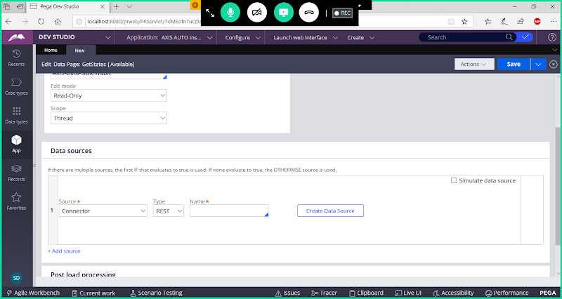

**Select Source Type as Report Definition**

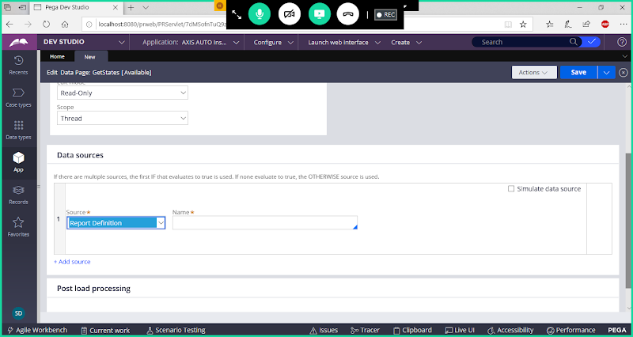

**Add Report Definition Rule name**

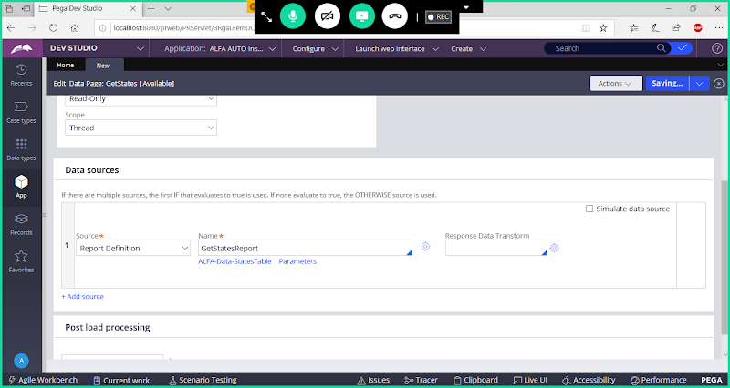

**Save Data Page Rule**

**Add Data Page under State Property Source in Customer Form & Vehicle Form:**

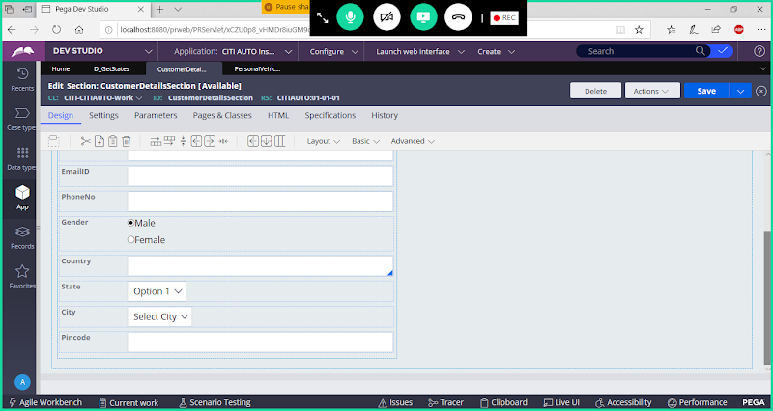

**Double click on State Property**

**Select Source Type as Data Page:**

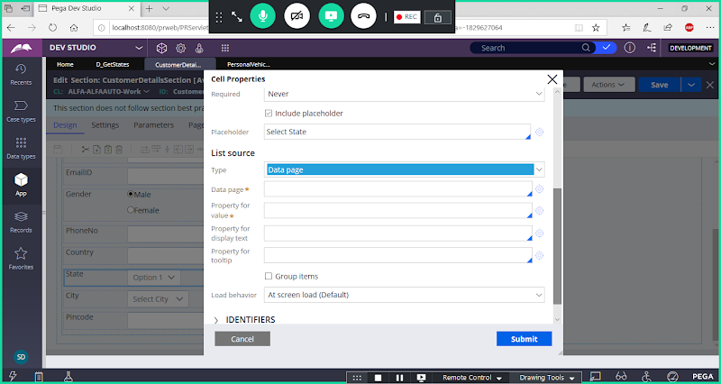

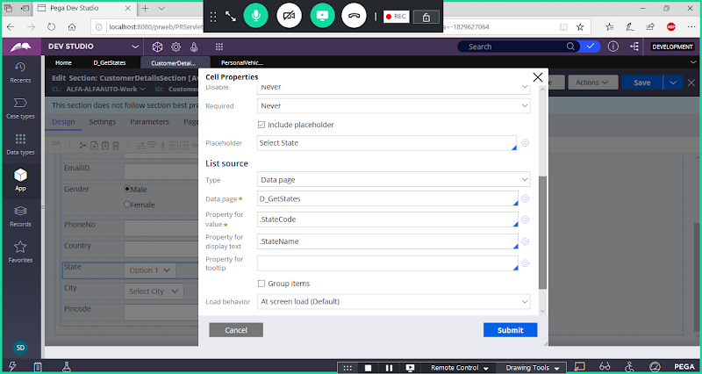

**Submit**

**Copy State Property From Customer Section to Personal Vehicle Section**

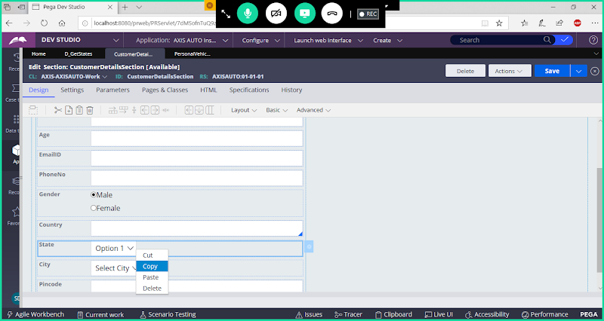

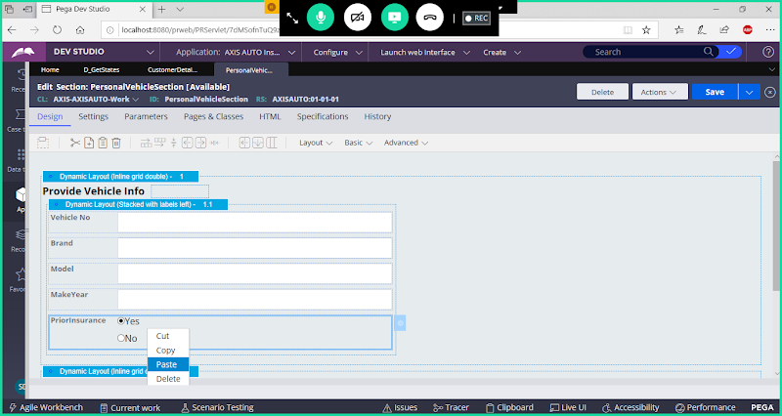

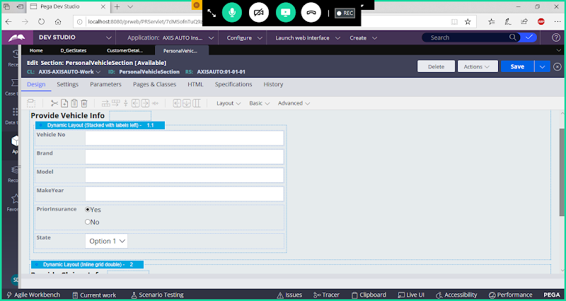

**Save Both sections**

**Run Insurance Flow & Debug using Tracer**

**Change Tracer Settings:**

**Update Tracer Settings:**

**Open Tracer from Footer/Toolbar Panel:**

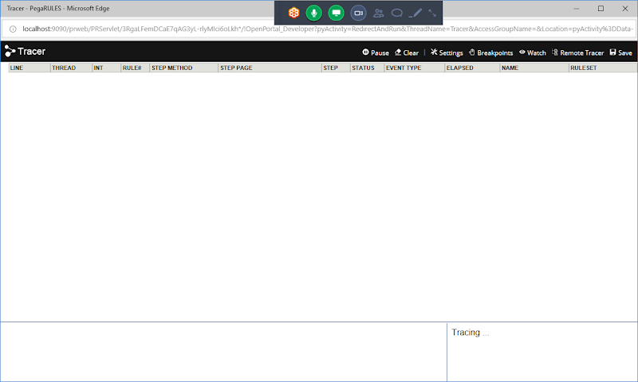

**Open settings in Tracer tool**

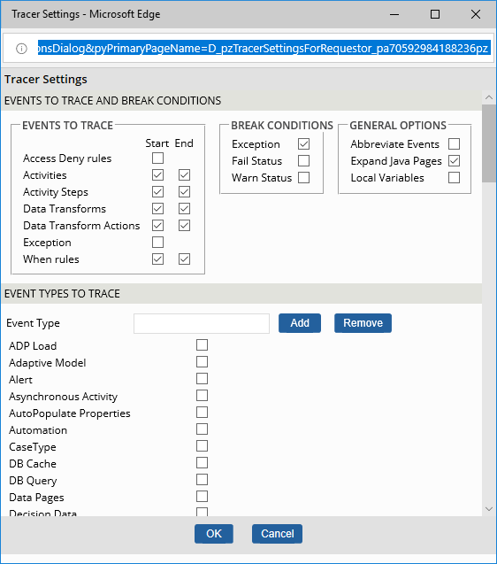

**Scroll down**

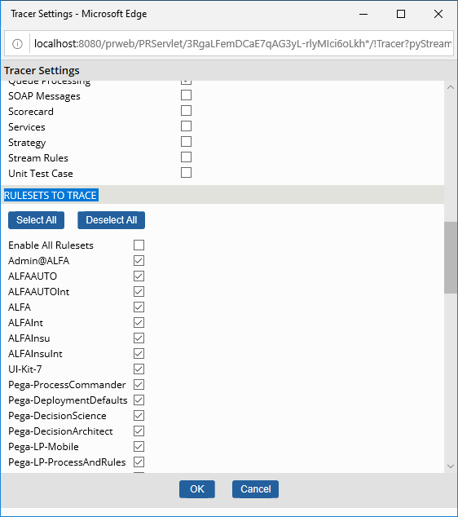

**Deselect All Rulesets**

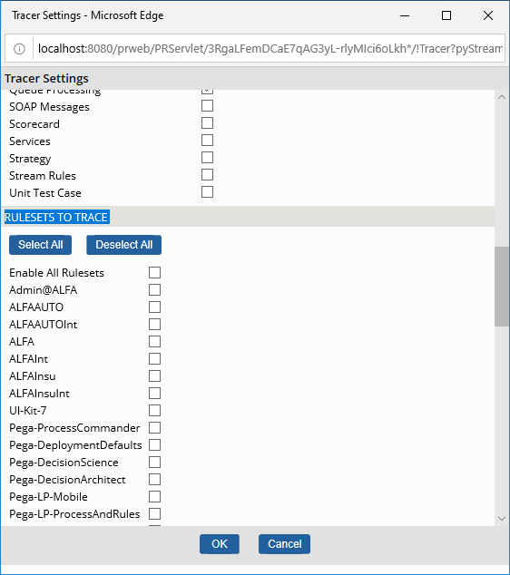

**Online Select User Defined Ruleset called ( ALFAAUTO ) -- Simalar to Division Class name u can find a Ruleset Name, select only that one.**

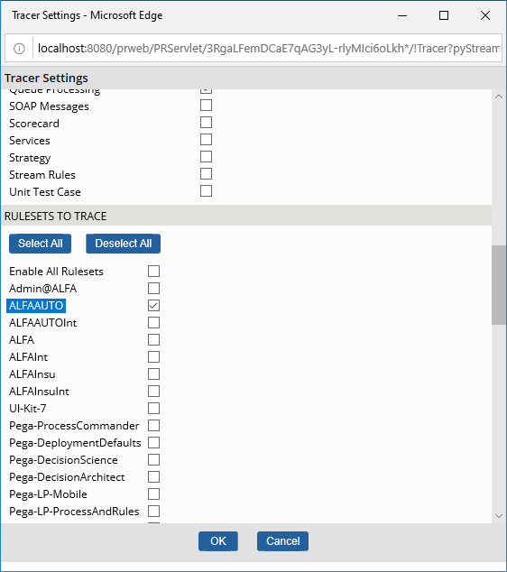

**Click on Ok.**

**Then Clear Tracer Logs**

**=======**

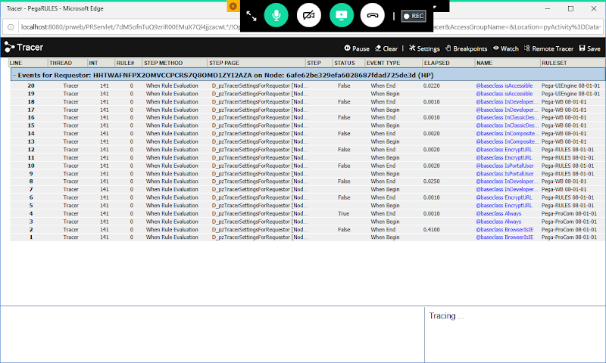

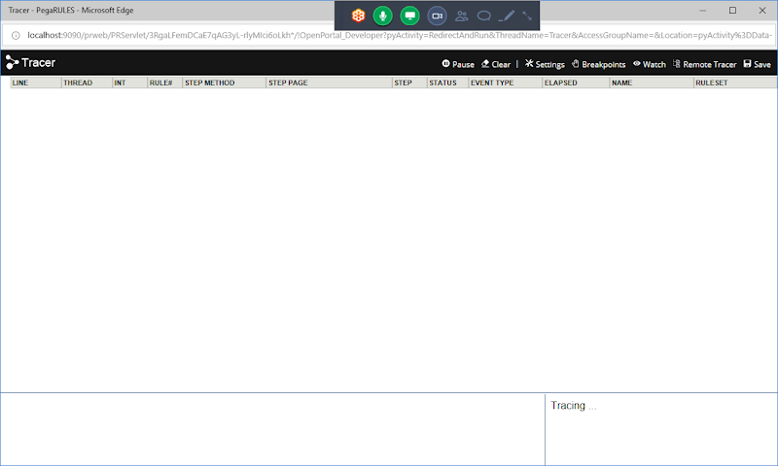

**Now Change Settings to Display Logs for the Data Page Rule**

**Open Tracer Settings**

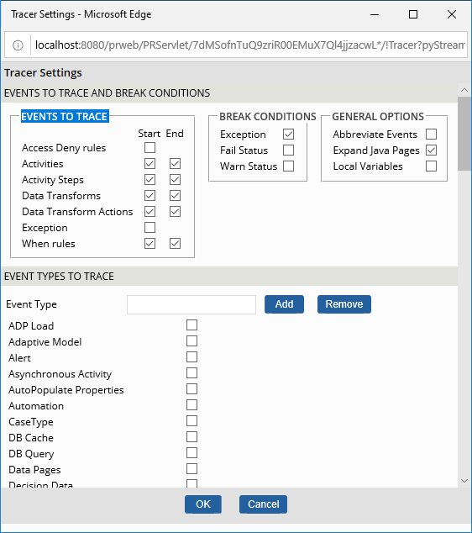

**Now Under Event Types to Trace Choose Data Page**

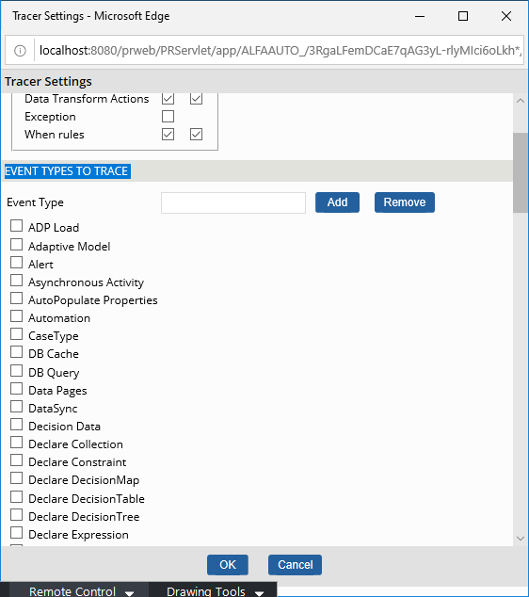

**Select Check box  for Data Pages option**

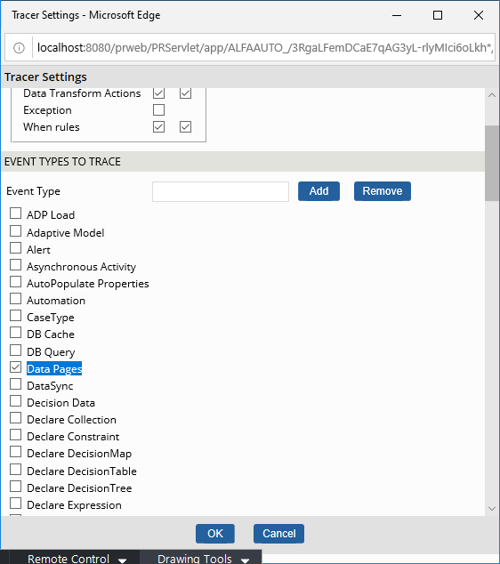

**Click on Ok**

**Now Run Insurance Flow**

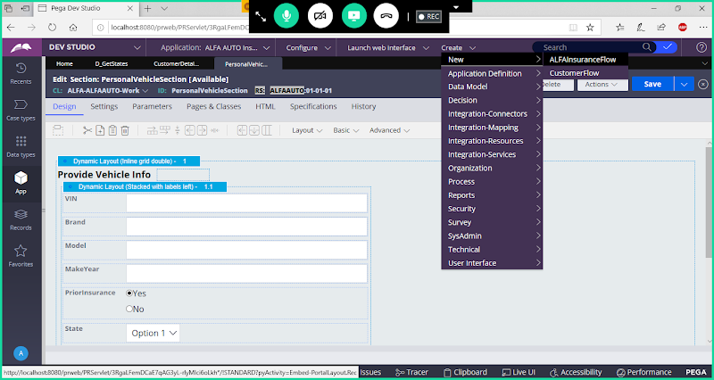

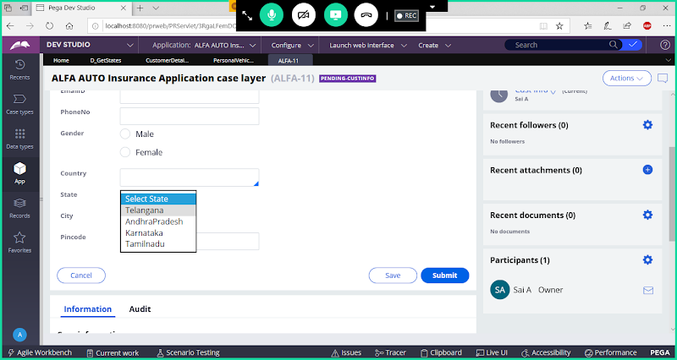

**Submit the WO**

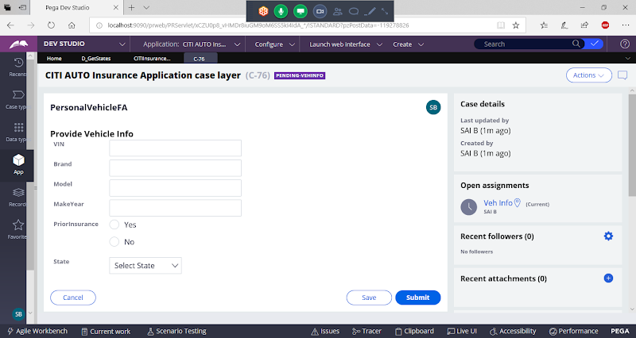

**Submit & Check Tracer Logs**

**Data Page Load begin: Means data loaded**

**Data Page Instance Found: Means data Copied**

**Tracer Logs for Thread Page:**

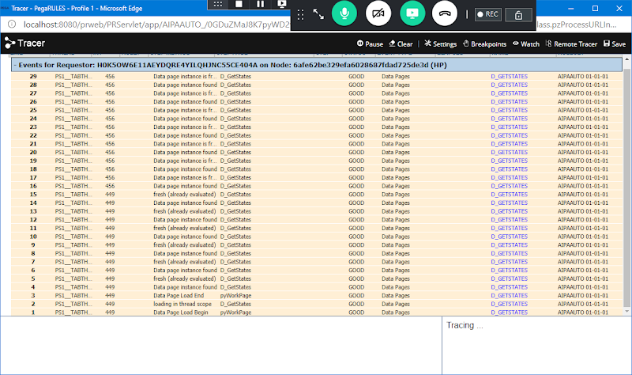

**-==============**

**Data Page - Requestor:**

**Open Data Page & Replace Scope Data Page Scope with Requestor:**

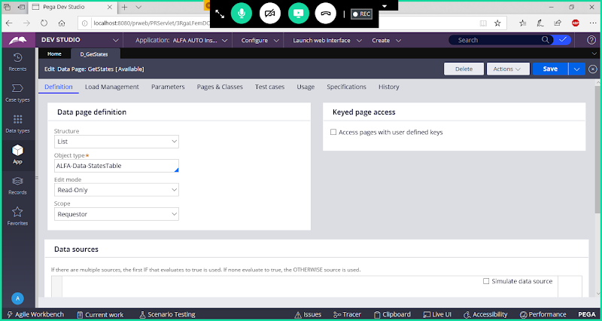

**Save Data Page**

**Run Flow & Check Tracer Logs**

**1 WO:**

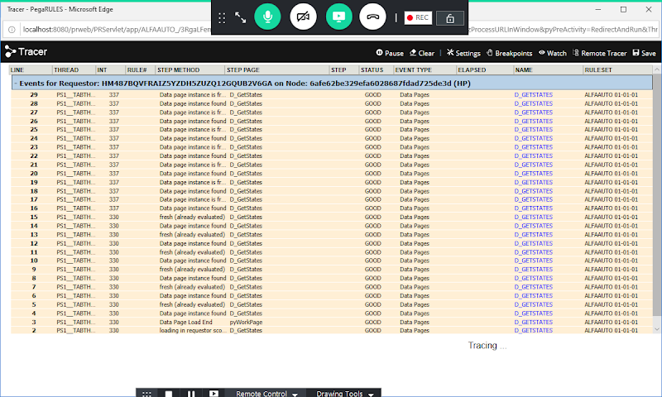

**2nd WO:**

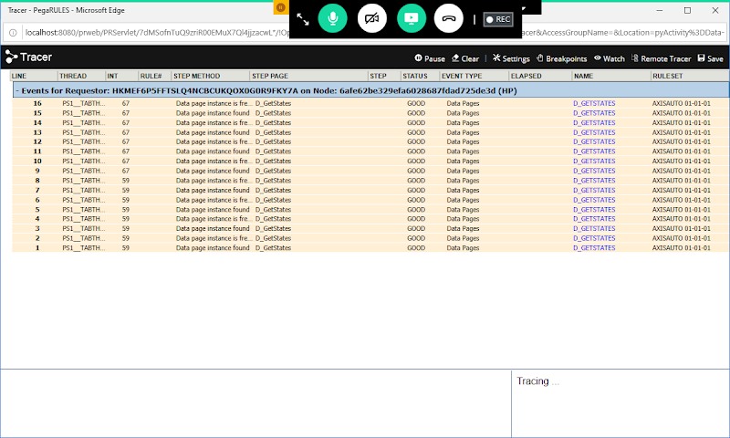

**Logoff & Login**

**3 WO:**

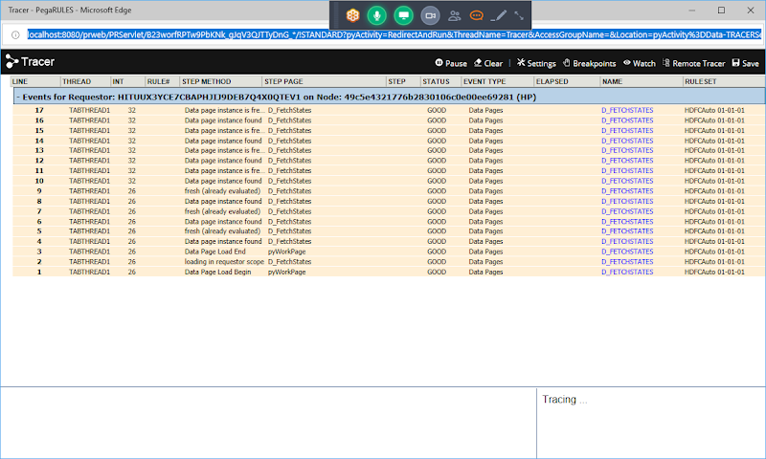

**Replace Data Page Scope with Node:**

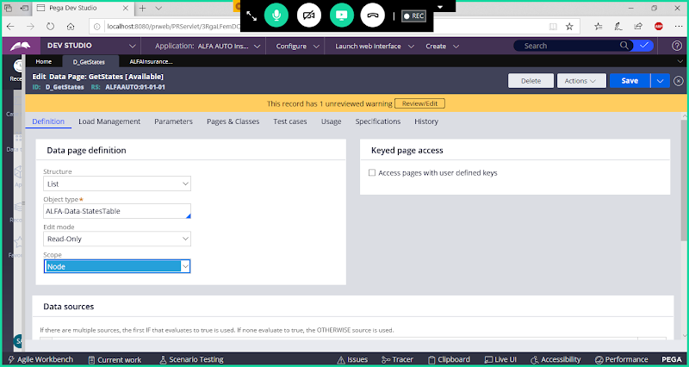

**Now Go to Load Management Tab & Add Access Group Name**

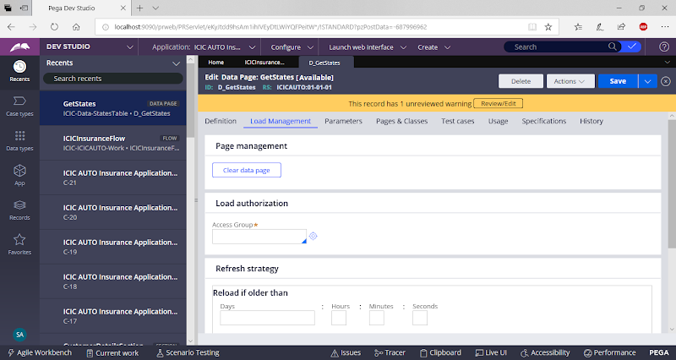

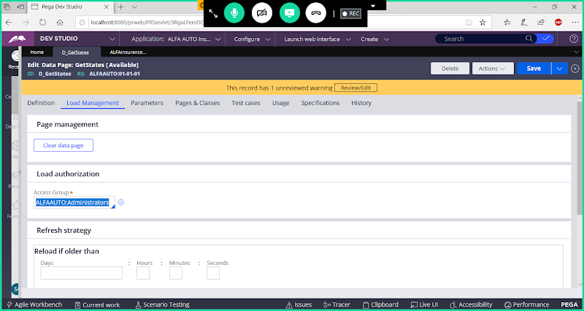

**Access Group Name:  Ex: DivisionName: Administrators**

**Save Data Page**

**Run Insurance Flow & Trace**

**Tracer Logs for Node:**

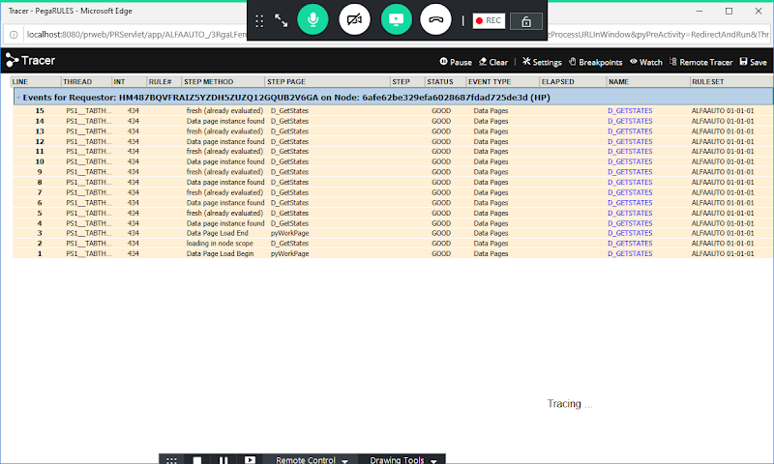

**Now Create Operator ID:**

**Open Existing ID & Use Saveas Option:**

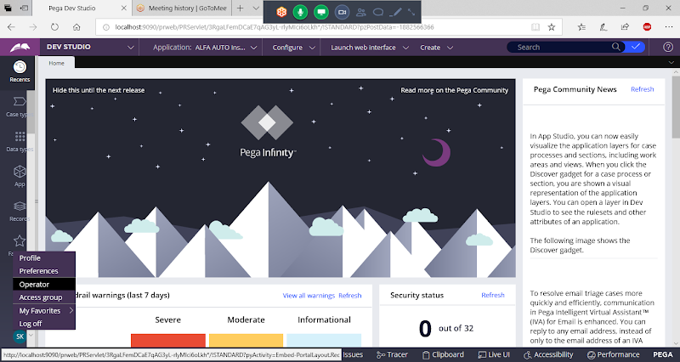

**Open Operator ID & Use Saveas**

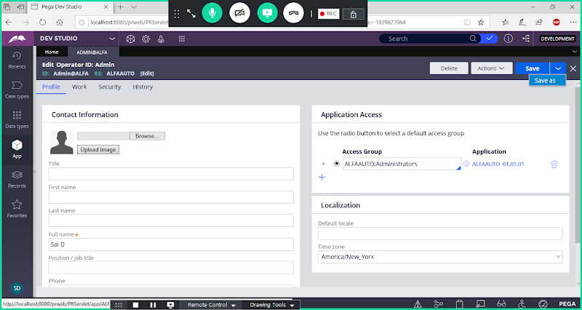

**Update User ID**

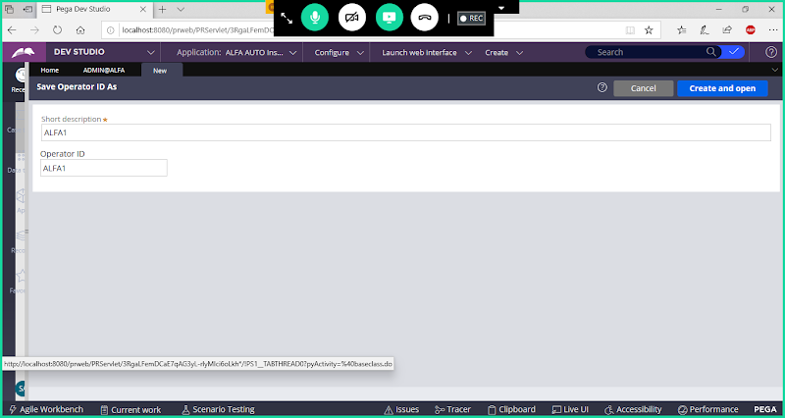

**Open & Update Full Name**

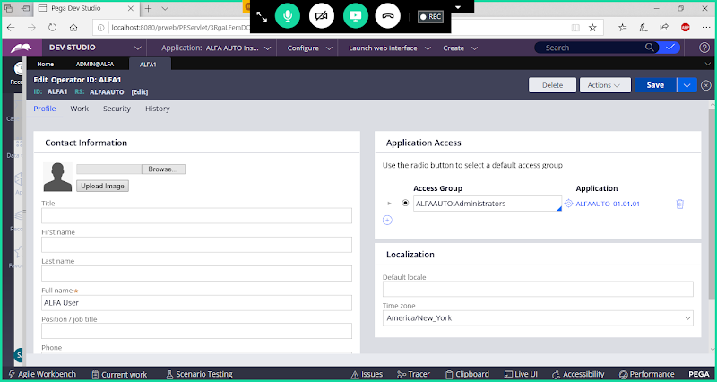

**Now Run Flow from New  User ID**

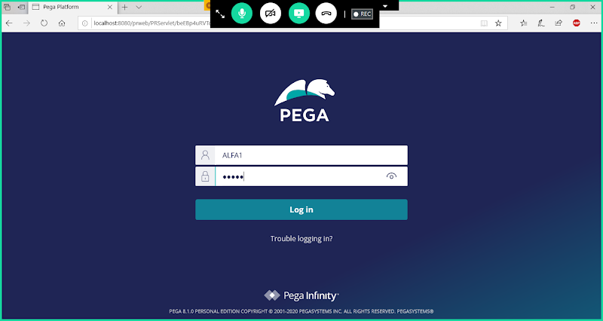

**Open & Update the Tracer Settings ( Select Only User Defined Ruleset & For Debugging Select Data Page)**

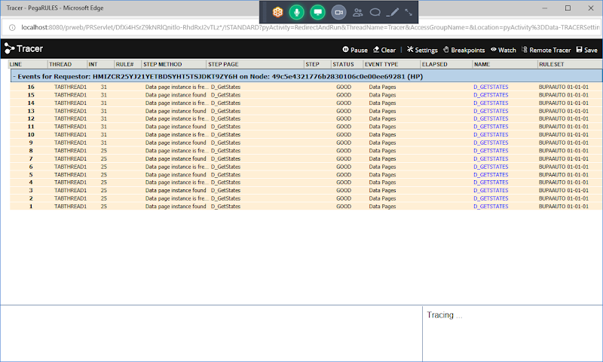

**===============**

**Login to New User ID:**

**ALFA1 , rules( password)**

**Execute Insurance Flow & Check Logs in Tracer**

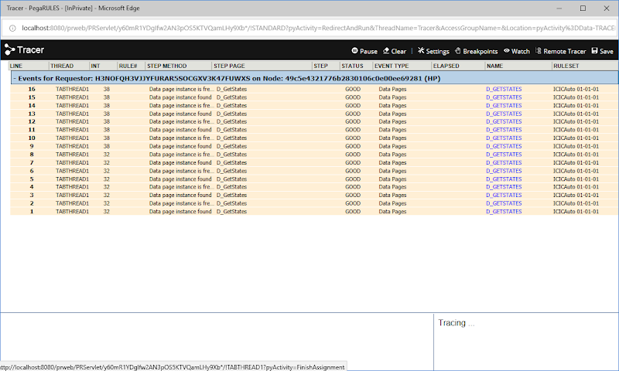

**Thread- With in One Flow in More than One page Load & Copy**

**Requestor:  with in one or More Pages  by one operator**

**Node: In Multiple Pages by multiple Operators**

**Report Definition: Only in 1 Page**

**Activity -Obj-Browse: Fetch & Others Actions**